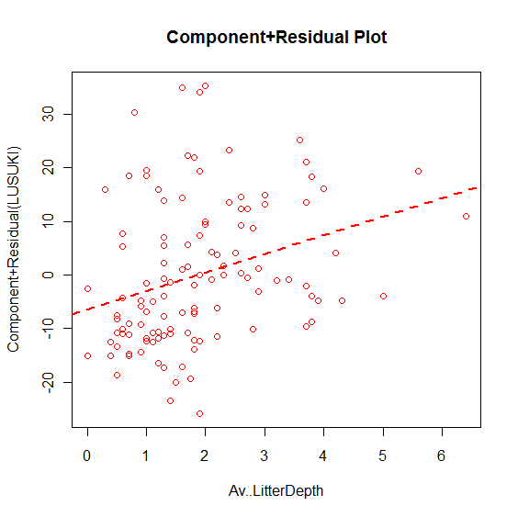After accounting for site, grass cover and scarification, increasing litter depth is correlated with increasing LUSUKI establishment (p=0.0065).

